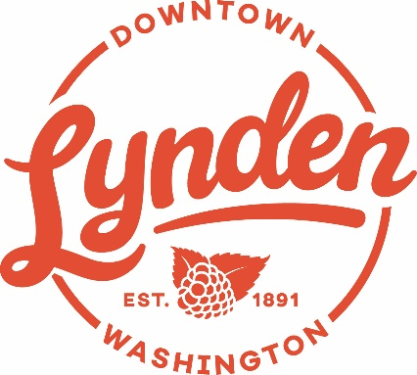
AGENDA

Friday, Feb. 14, 2020 — DLBA Meeting

7:00 AM at

Muljat Realty Conference Room
Agenda
- Welcome – Introductions and comments

- Review
- Approval of previous meeting’s minutes
- Board minutes for review
- Financial report-
- Christmas Lighting

- Chamber News

- Upcoming:
- Second notice membership letters going out this week
- Downtown benches soon to be powder coated

- City News and Update –
- Introducing Chief Steve Taylor, LPD
- 7th Street Update– Mark Sandal

- Association and Business News:
- Shelly Allen – web design business in addition to Bellingham Baby Co.
- New Business – Rustlers Front Street Grill (Kevin Seutz), 24/7 Parcel (Jeremy, George)
Aim & Game – Mpact45
- Spaces available – Former loc. of Meeple Manor and the space next to 24/7 Parcel, Central Tax

- New Website Demo – David Vos

- General discussion/sharing

DLBA Communication Forums:
Members Only Group – search Facebook groups for “members only Lynden DBA”
Open Group – public - https://www.facebook.com/LyndenDBA?fref=ts&ref=br_tf
DLBA Board Members: Deb McClure, Ken Stap, B.J. Westra, Tammy Yoder, Mary Compton, Jerry Blankers, Chuck Robinson, Vin Quinneville , Linda Van Diest

2020 Members (71 as of 2/10/20)

24/7 Parcel
Avenue Breads
Bellingham Baby Company
Blake Starkenburg (Vonstar Farms)
Bookkeeping Solutions NW
Canoe Street LLC- Dutch village mall
CHS Northwest
City Hair
Colony House Furniture
COAST
Compass Point Survey LLC
DeWagon Wasserij
Dickson Medical Clinic
Dr. Geoffrey T. Tupper DDS
Dutch Treat
Edward Jones Investments
E. J. building- W3 LLC
Elements Hospitality
Exceleration Driving School
Farmers Insurance
First Reformed Church
Forge Fitness
Groeneweg, Vree, & Co.
Homeward Designs
Inn at Lynden Forefront Hospitality
John Kamrar, Attorney
Journey Salon
JWR Design
K Engineers, Inc. Electrical Eng.
KATZ! Coffee & Used Books
Lynden's Barber Shop
Lynden Chamber of Commerce
Lynden Community Center
Lynden Performing Arts/DVM
Lynden Pioneer Museum
US Post Office - Lynden
Lynden Public Library
Lyndale Glass
Lynden Door
Lynden Dutch Bakery
Lynden Family Chiropractic
Lynden Service Center
Lynden Tribune & Print Company
Natural Way Chiropractic
New York Life Insurance Company
Nicole L. Terpstra, Attorney
Northwest Propane, LLC
Northwest Surveying & GPS, Inc.
Originals by Chad
Overflow Taps
Peoples Bank
Print Stop, Inc.
Reichhardt & Ebe Engineering
Rustlers Front Street Grill
Smith Kosanke & Wright, PLLC
Snapper Shuler Kenner Insurance
Starkenburg-Kroontje, Att.
State Farm Insurance
Stewart Tax and Accounting
Syros Greek & Italian Restaurant
Tangled Threads Quilt Shop Inc.
Telgenhoff & Oetgen P.S.
US Bank
Van Loo's Auto Service
Vander Giessen Nursery
Vander Griend Lumber Co. Inc.
Village Books/Paper Dreams
Whatcom Land Title
Wild and Wonder Boutique
Young Financial Services
Zylstra Tire Center Inc.

