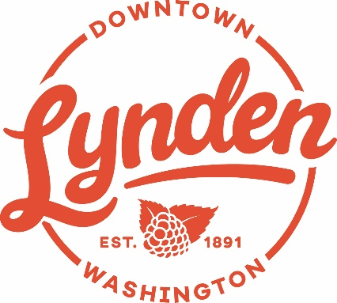
AGENDA

Friday, November 8th, 2019 — DLBA Meeting

7:00 AM at

Muljat Realty Conference Room

Agenda
- Welcome – Introductions and comments

- Review
- Approval of previous meeting’s minutes
- Financial report-
- DLBA membership
- Corporate update – Teri Treat
- Raspberry Festival/3on3 review
- Hot Thursday Nights / Hops Down Front review

- Upcoming Events:
- Chamber news
- Trick or Treat Downtown
- Christmas Lighting
- Elf on the Shelf

- City News and Update –
- Old WTP demolition
- 7th Street Update (July 31 out to bid) – Mark Sandal

- Business News:
- New Business – Symmetrie Studios, Lauckhart Building
- Spaces available – next to Lynden Door, next to Edward Jones, Dutch Village Mall, next to Meeple Manor,
- Bike rack update

- General discussion/sharing

DLBA Communication Forums:
Members Only Group – search Facebook groups for “members only Lynden DBA”
Open Group – public - https://www.facebook.com/LyndenDBA?fref=ts&ref=br_tf
DLBA Board Members: Teri Treat, Cheryl Hicks, Deb McClure, Ken Stap, B.J. Westra, Tammy Yoder, Mary Compton, Jerry Blankers, Chuck Robinson, Vin Quinneville , Linda Van Diest

2019 Members ( 91 as of 9/13/19 )

Avenue Breads
Bellingham Baby Company
Blake Starkenburg (Northwood Properties)
Blossoms
Bookkeeping Solutions NW
Central Tax and Accounting (Moved to B'ham)
Chandara House Restaurant
Cheeks Jeans
CHS Northwest
City Hair
Chuck Robinson Associates
Clean Water Services, LLC
Colony House Furniture
Compass Point Survey LLC
County Orthopedics & Sports Therapy
Creative Design Hair & Sculptured Nails
Creativitea
Canoe Street LLC- Dutch village mall
DeWagon Wasserij
Dickson Medical Clinic
Dutch Treat
Edward Jones Investments
Edward Jones building/W3 LLC
Elements Hospitality
Exceleration Driving School
Farmer's Insurance - Andy Jewell
First Reformed Church
Forge Fitness
Front Street Market
Dr. Geoffrey T. Tupper DDS
Gillies Funeral Home Inc.
Good to Go Meat Pies
Groeneweg, Vree, & Co.
Hats Off T-Shirts & Engraving, Inc.
Homeward Designs
Inn at Lynden Forefront Hospitality
JAG-Jaminson Advertising Group
Jansen Art Center
JoFish Restaurant
John Kamrar, Attorney
Journey Salon
JWR Design
K Engineers, Inc. Electrical Engineering
KATZ! Coffee & Used Books
Lyndale Glass
Lynden Chamber of Commerce
Lynden Community Center
Lynden Liquor
Lynden Performing Arts/DVM
Lynden Pioneer Museum
Lynden Public Library
Lynden Door
Lynden Dutch Bakery
Lynden Family Chiropractic
Lynden Service Center
Lynden Skateway
Lynden Tribune & Print Company
Lynden's Barber Shop (formerly Cliff's)
Muddy Waters
Muljat Group North Real Estate
Natural Way Chiropractic
New York Life Insurance Company
Nicole L. Terpstra, Attorney
Northwest Propane, LLC
Northwest Surveying & GPS, Inc.
Originals by Chad
Overflow Taps
Parts Warehouse
Peoples Bank
Porchlight Prop. Management LLC
Print Stop, Inc.
Reichhardt & Ebe Engineering
Smith Kosanke & Wright, PLLC
Snapper Shuler Kenner Insurance
Starkenburg-Kroontje
State Farm Insurance
Stewart Tax and Accounting
Sweet Peas Boutique
Syros Greek & Italian Restaurant
Tangled Threads Quilt Shop Inc
Telgenhoff & Oetgen P.S.
US Bank
US Post Office - Lynden
Van Loo's Auto Service
Vander Giessen Nursery
Vander Griend Lumber Co. Inc.
VibrantUSA
Village Books/Paper Dreams
Whatcom Land Title
Young Financial Services
Zylstra Tire Center Inc

